**Forecasting Financial Markets with Agent-Based Models**

Thomas Ankenbrand

thomas.ankenbrand@hslu.ch

# Abstract

***Keywords***: Financial Markets, Prediction, Agent-Based Model

***JEL classification:*** C63, G170, R20

Google Scholar

Microsoft Academic

ScienceDirect

SSRN

https://arxiv.org/

swisscovery RZS

To Do:

<https://www.social-complexity.com/>

<https://www.stephenwolfram.com/about/>

https://verbosus.com/bibtex-style-examples.html

# Introduction

*Positioning*

*Gap*

*Purpose*

*Central argument*

*Organizing*

*Contribution*

*So what?*

# Literature review

*Background*

*Conceptual scope*

*Definitions*

*Existing explanations*

*Critique*

*Open questions = current focus*

* 1. **Financial Markets**
  2. **Agent Based Models**
  3. **Oil**

Ellen and Zwinkels (2010) develop a heterogeneous agent model for the oil market. Decisions are formed by fundamentalist or chartist. Fundamentalists trade on mean-reversion of the moving average over a period of 24 months. Chartists follow the trend in prices. Speculators then choose between these rules based on past profitability. The model outperforms both the random walk and vector autoregressive models in out-of-sample forecasting. The agent-based model of Karimi and Maleki (2018) bases on 6 different rules to make price and trend predictions of oil: weekly U.S. commercial crude oil stocks, monthly OECD commercial crude oil stocks, daily USD/EUR exchange rate, simple moving average, exponential moving average, and Bollinger bands.

* 1. **SPI**

Lillo, Moro, Vaglica and Mantegna (2008) present behavioral data of the members of the Spanish Stock Exchange. They describe trend and contrarian types of agents. The agents show also herd behavior.

* 1. **Swiss Bond Market**
  2. **Swiss Real Estate Market**

Several studies describe agent-based models of housing markets (Geanakoplos et al. 2012; Jordan et al. 2012; Gilbert et al. 2009). Most of these models were built with the intention to help explain observable patterns such as spatial and social segregation, or spatial and temporal distributions of housing prices. These models typically combine demographic factors such as age distribution or family size with economic factors such as wealth distribution, income or level of debt. Sometimes, also psychological factors are included, for example value structures or changing fashions. From all these factors, agent behavior rules are deduced. Most of these models rely on a grid-like or map-based settlement representation with individual parcels and houses. Hedonic modelling, which also focuses on single real estate objects, is yet another, more traditional approach on which many real estate market studies rely. These studies typically try to derive information from aggregated data on real estate objects in a certain region or during a certain time period.

The real estate market in Switzerland is attracting much attention at the moment. Whereas over the past few years rising prices have led to high returns for investors and very little defaults for creditors, more recently concerns about the formation of a speculative bubble followed by a corresponding correction have increased. The real estate market in Switzerland is characterized by illiquidity and high transaction costs.

The consequences of a real estate crash are dramatic for everyone involved, and it takes years to recover. The established risk management practice is to focus on the acquisition phase of new real estate objects. Effective adjustments to an already existing portfolio are only possible in a relatively stable market environment. Otherwise they can come at a very high price with the added risk of unwanted counter effects, for instance lowering market prices by selling high volumes of real estate objects. For this reason, strategic planning over a time horizon of five to ten years is essential. Doing so again requires adequate forecasting and analysis tools that offer more than simple single measure forecasts, and instead can capture the complex, dynamic dependencies between the various constituent market factors. This is where simulation models can help. Agent-based modelling generates virtual worlds for what-if scenario analysis and stress testing.

Relevant investors are the 1654 pension funds with a balance sheet of CHF 988 bn. 2017, they have invested 9.5% of their assets in directly in Swiss real estate (8.2% Wohnimobilien and 1.3% Geschäftsimmobilien) and 7.6% indirectly over funds and stocks (OAK BV, 2018).

Wüest Partner (2019). Property Market Switzerland 2019.1. (available [www.wuestpartner.com/publikationen](http://www.wuestpartner.com/publikationen))

Kostadinov F. (2013): An agent-based model of a Swiss real estate market. Conference paper to be presented at the European Social Simulation Association (ESSA) conference Sept. 2013 in Warsaw.

* 1. **Crypto Currencies**

Gerlach, J.C., Gemost, G. & Sornette, D. (2018). *Dissection of Bitcoin's Multiscale Bubble History from January 2012 to February 2018.*

Yonghong, J., He, N. & Weihua, R. (2018). Time-varying long-term memory in Bitcoin market. Finance Research Letters.

Li, X. & Wang, C.A. (2016). The technology and economic determinants of cryptocurrency exchange rates: The case of Bitcoin.

Wu, K., Wheatley, S., & Sornette, D. (2018). Classification of cryptocurrency coins and tokens by the dynamics of their market capitalizations. Royal Society Open Science, 5(9), 180381.

Cocco, L., Concas, G., & Marchesi, M. (2017). Using an artificial financial market for studying a cryptocurrency market. Journal of Economic Interaction and Coordination, 12(2), 345-365.

Alessandretti, L., ElBahrawy, A., Aiello, L. M., & Baronchelli, A. (2018). Machine learning the cryptocurrency market. Available at SSRN 3183792.

Alessandretti, L., ElBahrawy, A., Aiello, L. M., & Baronchelli, A. (2018). Anticipating cryptocurrency prices using machine learning. Complexity, 2018.

* 1. **Multi market models**

Ray Dalio

Joyce, M. A. S., Lasaosa, A., Stevens, I., and Tong, M. (2011). The financial market impact of quantitative easing in the United Kingdom. International Journal of Central Banking, 7(3), 113-61.

The market environment enables us to first simulate inter market relations. Second, we can compare these simulations to time series of the real financial markets around the world. In this manner, we evaluate the goodness of our model – it is assumed to be a suitable model the better it captures ex post real world market processes/ outcomes.

# Methodology

* *Summary of argument*
* *Overview of model*
* *Detailed justification*
* *Hypotheses*
  1. **Financial Markets**
  2. **Agent Based Models**

Dynamic trading ratio (depending on success)

Alpha Hypothesis

* Shorter time means less risk
* Averaging
* Volatilitäts Clustering
* Risk Parity
* Position also from strength of trading signal depending
* Threshold Values for trading

Utility function Kahnemann/Tversky (Lo, 2017, 58)

Probability Matcher instead of Buy and Hold (Lo, 2017, 193f) for Risk Mgmt

Shannon’s Demon

* 1. **Oil**

* 1. **SPI**

The Swiss Performance Index (SPI) is the broad index of the Swiss stock market. It includes approximately 230 equity issues. The included stocks must be primary listed in Switzerland and must have a free-float equal to or greater than 20 percent. The calculation method is the capital-weighted Laypeyres formula based on the freefloat. The full market capitalization was CHF 1’553 billion and free float adjusted CHF 1’353 billion (as of 29.12.2017). (SWX, 2018)

Owners of the SPI stocks are private households, institutional investors like pension funds, insurance companies and banks, and cooperation/government. Household and institutional investors can hold the equities direct or indirect. For that reason, relevant investors are investment advisors and fund managers which hold the equities behave of their clients. Based on different datasources (Bloomberg, 2018; OAK BV, 2018; SNB, 2018) the following simplified ownership structure is used:

* Private Housholds 10% direct 25% indirect
* Institutional Investors 10% direct 25% indirect
* Cooperations/Government 30% direct

The performance of the followings models are compared:

* A neural network model (Ankenbrand, 1995a; Ankenbrand, 1995b)
* A linear regression model (Ankenbrand, 1998, 65ff)
* A neural network model (Ankenbrand, 1998, 67)
* Kernel Regression (unpublished)
* David Maturaarbeit

The specification of the neural network model is (Ankenbrand, 1995a)

*x(t+1) – x(t) = f(du(t), ich(t) – ich(t-1), s(t) – s(t-1))*

where

*x* is the SPI

*du* is the DEMUSD exchange rate

*ich* is the Bond CH yield

*s* is the S&P 500.

The specification of the linear regression model is (Ankenbrand, 1998, 65)

*x(t+1) – x(t) = 0.0008(d(t) – d(t-1)) – 0.7(ich(t) – ich(t-1)) – 0.4(ius(t) – ius(t-1)) – 0.1(ij(t) – ij(t-1))*

where

*x* is the SPI

*ich* is the Bond CH yield

*ius* is the Bond US yield

*ij* is the Bond J yield

*d* is the DAX.

The in-sample data are from January 1987 to December 1996 on a monthly basis.

Base on Ankenbrand (1998) the following investors are in addition to trend follower tested: DAX, Bond US, Bond YEN, Bond CHF, EURUSD and S&P 500. The highest improvement is the S&P 500 delivering.

Feng, Gigilio and Xiu (2020) test 150 factors on their influence on stock prices.

* 1. **Swiss Bond Market**
  2. **Swiss Real Estate Market**

The agents are grouped in three different classes representing real-world investors: Institutional investors, private residents or self-users and trend followers or speculators. Depending on their class, agents invest in either the SWX IAZI Investment Real Estate Price Index (SI Investment PR; IAZI, 2014a), and/or SWX IAZI Private Real Estate Price Index (SI Private PR; IAZI, 2014b). To make trading decisions, they rely on a set of both technical and fundamental factors based on the movements of different time series[1]. Their decision includes whether to buy or sell the index or alternatively to take no action. Table 1 gives an overview on all agent classes, the index they trade and the time series they use as input decision factors.

Table 1: Agent classes, traded indices and input decision factors

|  |  |  |  |
| --- | --- | --- | --- |
| *Agent class* | **Institutional Investors** | **Private residents/ self-users** | **Trend followers/ speculators** |
| *Characteristics* | * Insurance companies, pension and real estate funds * A mid- to long-term investment perspective * Low leverage * Investment in property as an alternative to bonds or stocks * Perform technical and fundamental analysis | * Potential land- and house owners who buy real estate for their own, private use * A long-term perspective | * Trade real estate for speculative reasons * Always follow the markets’ trends * Short-term investment perspective * Rely on technical analysis |
| *Market/ traded index* | * SI Investment PR | * SI Private PR | * SI Investment PR * SI Private PR |
| *Decision inputs* | * SI Investment PR * Swiss rental price index * Swiss Bond Index * MSCI World Index * Swiss population | * SI Private PR * Swiss rental price index * Swiss Bond Index | * SI Investment PR only or SI Private PR only |

Source: Kostadinov and Ankenbrand (2013a)

Instead of using long term interest rates (Swiss Bond Index) it would be interesting to test short term interest rates as an independent varianle (Sutton et al., 2017).

Immobilien Zyklus The Secret….

* 1. **Crypto Currencies**
  2. **Multi market models**

The performance of the followings models are compared:

* Static ABM model (Ankenbrand, 1997; Ankenbrand, 1998, 91ff)
* Dynamic ABM model (Ankenbrand, 1998, 91ff)
* Complex ABM model (Ankenbrand, 1998, 91ff; Ankenbrand, 1999)
* AVACO Global Macro (unpublished)
* An Information theoretic approach weekly data YENUSD (Ankenbrand, 1999)

Ankenbrand, T. & Klan, P. (1999). Application of information in financial markets prediction. Barcelona: FMA European Conference.

# Results

*Logic of research design*

*Description of measurement and/or observation procedures*

*Validity and reliability tests*

*Analytical procedures*

*Description of the data – context, units of analysis, site, sample, appropriateness*

*Descriptive*

*Statistical or qualitative patterns*

*Inferences and implications*

* 1. **Oil**
  2. **SPI**

Results, but to verify in AVACO SPI V0.xlsm

Lansing and Tubbs (2018) describe a multiplicative combination of sentiment and momentum to predict the return on the Standard & Poor’s 500 stock index over the next month. SPI has to be tested.

* 1. **Swiss Bond Market**

Based on Ankenbrand (1998) the following agents are in addition to the buy and hold tested: Bond CH, 3 M CHF, Bond US, DAX, Spread CH, Spread USD. The actual model is buy and hold agent and a trend follower.

The volume of the Swiss Bond market is CHF 500 Mio.. Investors are

* Banks
* Insurance companies
* Pension companies
* Fonds
* Retail

Swiss Bonds has often a safe haven function in uncertain times (Nitschka, 2014).

## **Swiss Real Estate Market**

We ran the ABM model over a time period from December 1986 to September 2014, resulting in 110 trading rounds. Table 2 gives an overview of the results:[2]

Table 2: Simulation results: Model quality measures

|  |  |  |
| --- | --- | --- |
|  | **SI Investment PR** | **SI Private PR** |
| **Observed upward price changes** | 59 | 66 |
| **Observed downward price changes** | 51 | 44 |
| **Generated BUY signals** | 63 | 74 |
| **Generated SELL signals** | 47 | 36 |
| **Hits** | 84 | 85 |
| **Misses** | 26 | 26 |
| **Hit rate** | 0.75 (75%) | 0.75 (75%) |
| **Model efficiency** | 0.54 (54%) | 0.54 (54%) |

Investment Real Estate Price Index (SI Investment PR), and Private Real Estate Price Index (SI Private PR)

For both observed indices, the SI Investment PR and the SI Private PR, the hit rate has a value of 0.75. This means that in 3 out of 4 quarters the trend prediction of the Swiss real estate market was correct. Although the hit rate gives an overall impression of the number of correctly predicted price movements, it does not say anything about the relative size of these movements and the resulting potential gains and losses. As is well known, a single big drawdown can nullify a whole series of precedent gains. The current model efficiency is 0.54 for the SI Investment PR and 0.54 for the SI Private PR. The economic meaning is the relation between the realized and the possible profit and is 54%. The presented ABM therefore indicates a high degree of reliability.

A criticism of agent-based models is that there are too many degrees of freedom (LeBaron, 2006). The parameter space can be reduced through a stringent economic foundation and an evolutionary control of the development of the parameters.

Besides producing trend predictions for the next quarter, the model can be used for long-term scenario analysis and stress testing. In the following example, the effects of a long-term rise in interest rates on the SI Investment PR and SI Private PR are analyzed. The simulation is run up to the last quarter end (Q3 2014) relying on historical data. The interest rates are continuously increased as an example scenario. From this point on, the output time series (SI Investment PR and SI Private PR) is generated by the model. Figure 3 shows the outcome of the simulation runs for both target indices and also the yield of the Swiss Bond Index as the varied input measure during the period from December 1986 to September 2014.

Figure 3: Scenario analysis results

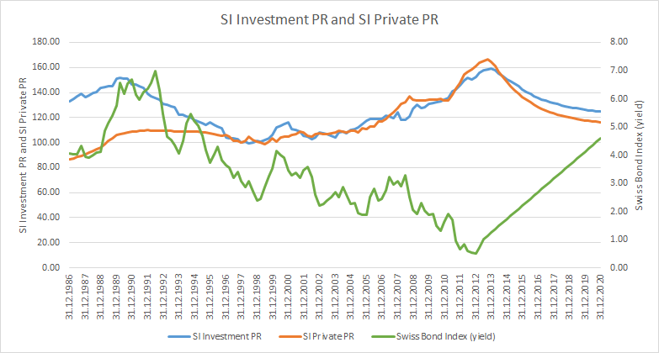

For both indices, a long-term increase of the interest rates leads to a clearly observable and significant decrease of both indices.

In a situation lacking both positive as well as negative market forces, the simulated market is nevertheless inclined towards a negative correction. The reason is that the majority of agents have already invested in real estate, and their potential to adding further assets to their existing investment portfolio is limited due to monetary limitations. The maximum affordable purchase of an average Swiss household at the end of 2014 was CHF 734’000. At the same time the price for an average property was CHF 800’000. The broad population isn’t any more able to buy a property with the solid financing (Keating and Hasenmaile, 2015).

If however negative market impulses prevail, a significant negative correction is to be expected according to our simulation results. Therefore, according to the model a further long-term rise in the Swiss real estate markets is to be expected only in a regime of prolonged, strong and positive market forces. Our conclusion goes in the same line with Toivonen and Viitanen (2015), which consider that when market actors are aware of the forces appearing in their action environment, they are able to notice any new phenomena emerging and quickly adapt their actions and even steer the development to the desired direction.

Unlike the other countries shown in figure 2, in Switzerland real estate prices continued to rise also in the years 2007 to 2014. Given the finding that in real estate cycles the downturn phase mirrors the preceding upturn phase, and assuming that the cycle’s tipping point was reached today, then both indices can be projected into the future. These projections actually correspond well with the simulation results provided by our agent-based model of the Swiss real estate market in figure 3. As we have argued above, prices will either continue to rise or otherwise they will fall, but a prolonged sideways movement is not very probable.

If however negative market impulses prevail, a significant negative correction is to be expected according to our simulation results. Therefore, according to the model a further long-term rise in the Swiss real estate markets is to be expected only in a regime of prolonged, strong and positive market forces. The scenario analyses indicate that the Swiss real estate market is in a rather weak condition. In the absence of positive market forces, the market has a tendency towards a negative correction, which becomes more poignant in the presence of negative market forces such as rising interest rates. In the simulated scenarios, increasing interest rates can lead to a strong negative correction of the real estate markets.

The AVACO model fits very well to the development of the Swiss real estate market since 1986. It can be used for forecasting in asset management and for scenario analysis in risk management. Scenario analyses conducted by AVACO indicate that the Swiss real estate market is in a rather weak condition. In the absence of positive market forces, the market has a tendency towards a negative correction, which becomes more poignant in the presence of negative market forces such as rising interest rates. In the simulated scenarios, increasing interest rates can lead to a sharp correction of the real estate indices.

## **Crypto Currencies**

* 1. **Multi market models**

The model covers an international set of currency, bond, equity and commodity markets for the time between January 1982 and September 2014 on a monthly basis.

We include the following markets:

• Currency markets: EUR/USD, YEN/USD, EUR/CHF

• Bond markets: United States, Euro Area, Japan, Switzerland

• Equity markets: S&P 500, DAX, Nikkei 225, SPI

• Commodity markets: Gold and oil

This market environment covers the main financial regions and instruments with a Swiss bias. Only one good is traded in each market. This is realistic and easily understandable for the currencies exchange markets. However, the bond and stock markets are simplified because there is only one asset traded in each market, whereas in reality different stocks and bonds are traded in one single market. While this assumption is simple, it is also realistic because it amounts to a situation similar to trading an index (future).

To make trading decisions, the agents in our model rely on a set of both technical and fundamental factors based on past movements of different time series. They decide to either buy or sell an asset, or to take no action at all. We model two types of agents: Fundamentalist and technical traders. Table 1 provides an overview of all agent classes, their characteristics, the market they trade in and the time series they use as input decision factors.

|  |  |  |
| --- | --- | --- |
| ***Table I.* Agent Classes** | | |
| Market | Technical | Fundamentalist |
| EURUSD | Trend follower with lag 1  Trend follower with lag 3 | Input Oil  Input YENUSD |
| YENUSD | Trend follower with lag 1  Trend follower with lag 3 |  |
| EURCHF | Trend follower with lag 1 | Input S&P 500  Input Oil |
| Bond USD | Trend follower with lag 1  Contrarian with lag 1 | Input EURUSD  Input EURCHF |
| Bond EUR | Trend follower with lag 1  Trend follower with lag 3 | Input EURUSD  Input YENUSD  Input S&P 500 |
| Bond YEN | Trend follower with lag 12  Contrarian with lag 6 | Input S&P 500  Input Nikkei 225 |
| Bond CHF | Trend follower with lag 1  Contrarian with lag 1 | Input EURUSD |
| S&P 500 | Trend follower with lag 1  Trend follower with lag 6  Trend follower with lag 12 | -Input Bond USD  Input Gold |
| DAX | Trend follower with lag 1  Trend follower with lag 12 | Input Oil |
| Nikkei 225 | Trend follower with lag 1  Trend follower with lag 6 | Input EURCHF  Input Oil |
| SPI | Trend follower with lag 1  Trend follower with lag 6  Trend follower with lag 12 | Input EURCHF |
| Gold | Trend follower with lag 6  Trend follower with lag 12 |  |
| Oil | Trend follower with lag 3  Trend follower with lag 6 | Input EURUSD  Input Gold |
| This table give an overview of the used agents. The trend follower decide on the time series itself with a certain time lag. The fundamentalist compares the value to the traded time series with the value of the input time series. | | |

There are different agents for every market with different trading profiles, trading rules and home currencies. The agents are simple reactive agents in the present model who use past prices as input to their trading decision before executing their output, which is an order they place in the order book in every trading cycle. They do not have any information about the behavior of the other agents in the model except for the (past) price movements of different assets.

The Fed’s QE actions are implemented by including an additional central bank agent buying assets. The Figure 1 shows the timeline of its QE actions and the total outstanding volume of the Fed transactions.

Fed Quantitative Easing

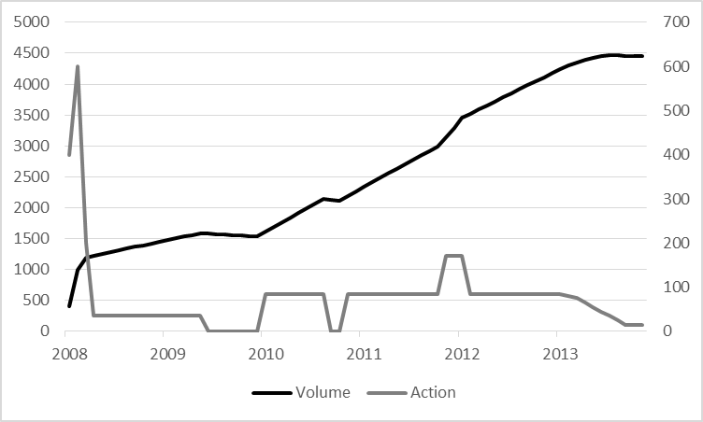

***Figure 1.* Fed Quantitative Easing Actions**

This figure shows Fed Quantitative Easing monthly actions and the total volume of the actions between 2008 and 2014.

Based on this timeline the Fed agent is buying the different asset classes.

The results outlined in Table 2 clearly show that our “basic” model captures well the global market developments during the sample period considered.

|  |  |  |
| --- | --- | --- |
| ***Table 2. Performance Results of the original agent-based Model*** | | |
| Market | Hit Rate | Model Efficiency | |
| EURUSD | 55.8% | 18.7% | |
| YENUSD | 56.5% | 18.8.% | |
| EURCHF | 51.4% | 6.9% | |
| Bond USD | 65.0% | 32.6% | |
| Bond EUR | 63.4% | 36.0% | |
| Bond YEN | 62.1% | 33.0% | |
| Bond CHF | 62.9% | 35.9% | |
| S&P 500 | 59.1% | 22.6% | |
| DAX | 58.1% | 22.3% | |
| Nikkei 225 | 48.8% | 13.4% | |
| SPI | 61.9% | 28.1% | |
| Gold | 52.2% | 16.9% | |
| Oil | 52.9% | 15.7% | |
| This table reports empirical results for monthly data. The sample period runs from January 1982 to September 2014. | | |

Building up on this, Table 3 shows the results of the ABM that includes the Fed and their respective QE actions. It can clearly be seen that their actions improve the overall model results. The Fed’s QE has an impact on the markets for currencies and stocks. Surprisingly, it does not affect the bond markets. Our model therefore shows that QE measures undertaken in the United States have produced asset bubbles in the stock markets.

|  |  |  |
| --- | --- | --- |
| ***Table 3 Performance Results of agent-based Model with the Fed as agent*** | | |
| Market | Hit Rate | Model Efficiency | |
| EURUSD | 56.8% | 28.4% | |
| YENUSD | 57.8% | 20.6% | |
| EURCHF | 51.4% | 6.9% | |
| Bond USD | 65.0% | 32.6% | |
| Bond EUR | 63.4% | 36.0% | |
| Bond YEN | 62.1% | 33.0% | |
| Bond CHF | 62.9% | 35.9% | |
| S&P 500 | 60.1% | 26.4% | |
| DAX | 59.8% | 29.2% | |
| Nikkei 225 | 51.4% | 18.0% | |
| SPI | 62.4% | 30.8% | |
| Gold | 52.2% | 16.9% | |
| Oil | 52.9% | 15.7% | |
| This table reports empirical results for monthly data. The sample period runs from January 1982 to September 2014. | | |

In order to predict possible effects of QE in the Euro Area as announced on October 2, 2014, by the ECB into our modelling framework:

The program starts in October 2014.

It will last at least two years.

It will have a sizeable impact on the ECB’s balance sheet.

Based on these assumptions, we develop the following scenario.

Figure 2 shows a timeline for constant QE actions of a total outstanding volume of up to EUR 1 billion.

ECB Quantitative Easing

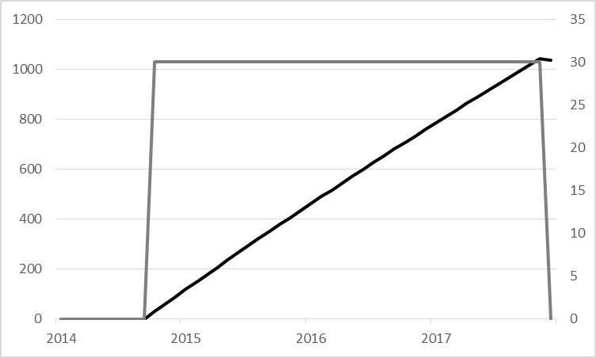

***Figure 2.* ECB Quantitative Easing Actions**

This figure shows ECB Quantitative Easing monthly actions and the total volume of the actions between 2014 and 2017.

Figure 3 shows the long term simulated stock market time series on this timeline.

Stock price indices

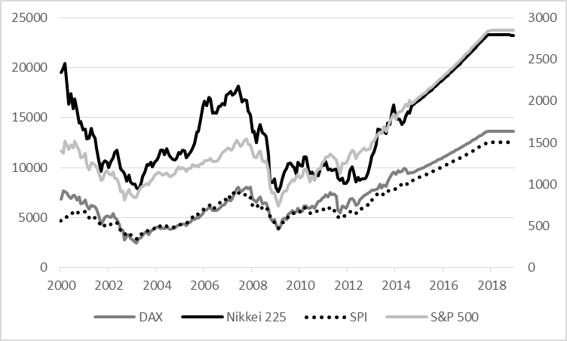

***Figure 3.* ECB Quantitative Easing Actions**

This figure shows the simulation of Stock price indices from October 2014 to December 2018. All indices are based on monthly data for the sample period from January 1982 to September 2014.

This paper employs a multivariate agent-based model of a broad set of international financial markets to model the effect of quantitative easing (QE) actions undertaken by the Fed. Moreover, we use its results to simulate the impact of QE measures by the ECB on market movements as announced by the ECB in early October 2014. Based on relatively simple assumptions about our agents’ behavior, the model is capable of mirroring well key events in international financial markets. It therefore allows the long term simulation of different markets, their interaction, contagion of shocks and behaviour in times of crises. Most importantly, back testing of our model’s predictions with past data clearly shows that including QE in its framework improves it. Moreover, we can then use it to predict an international stock market rally induced by the ECB’s unconventional monetary policy.

# Conclusion

* *Summary and interpretation of results*
* *Main contribution to the core audience*
* *Contributions to peripheral audience*
* *Limitations – boundaries*
* *Future research*

**References**

Allen, P.M. (1994). Evolutionary Complex Systems. Models of Technology Change. In Leydesdorff, L., & Van den Besselaar, P. (Ed.). Evolutionary Economics and Chaos Theory. London: Pinter.

Andersen, J. V., & Sornette, D. (2005). A Mechanism for Pockets of Predictability in Complex Adaptive Systems. *Europhysics Letters, 70(5),* 697-703.

Ankenbrand, T. & Tomassini, M. (1995a). Multivariate time series modelling of financial markets with artificial neural networks. In Pearson, D.W., Steele, N.C., Albrecht, R.F.: *Artificial Neural Nets and Genetic Algorithms*. Springer, 1995.

Ankenbrand, T. & Tomassini, M. (1995b). Neural Networks and Statistical Forecasting of Multivariate Economical and Financial Time Series. *Neural Network World*. IDG, 1995.

Andrikogiannopoulou A. and Papakonstantinou F. Are behavioural bias stable across markets and prelavent across individuels? Evidence from individuel betting choices [Journal]. - 2010.

Bundesamt für Statistik (2013): Mietpreisindex. Schweizerisches Bundesamt für Statistik BFS. Data obtained from <http://www.bfs.admin.ch/bfs/portal/de/index/themen/05/06/blank/key/index.html>

Busoniu, L., Babuska, R. & De Schutter, B. (2008). *A Comprehensive Survey of Multiagent Reinforcement Learning.* IEEE Transactions on Systems, Man, and Cybernetics, Part C (Applications and Reviews) ( Volume: 38 , Issue: 2 , March 2008 )

Chiarella C., Dieci R., He X.Z. (2009). Heterogeneity, market mechanisms, and asset price dynamics. In: Hens T., Schenk-Hoppé K.R. (Eds.), Handbook of Financial Markets, North Holland, SanDiego, pp.277–344.

Detzel, A., Liu, H., Strauss, J., Zhou, G. & Zhu, Y. (2018). Bitcoin: Learning, Predictability, and Profitability via Technical Analysis.

Dosi, G., Fagiolo, G, Napoletano, M. & Roventini, A. (2012). Income Distribution, Credit and Fiscal Policies in an Agent-Based Keynesian Model. Retrieved December 27, 2018, from https://papers.ssrn.com/sol3/papers.cfm?abstract_id=1990209

Fama, E. F. (1991). *Efficient Capital Markets: II.* The Journal of Finance, Vol. 46(5), 1575-1617.

Farmer, J.D. & Sidororwich, J.J. (1988). Can New Approaches to Non-linear Modelling Improve Economic Forecast. In Anderson, P.W., Kenneth, J.A, & Pines, D. (Ed.). The Econonomy as an evolving complex System. New York: Addison-Wesley.

Farmer, J.D. (2002). Market force, ecology and evolution. In Industrial and Corporate Change, Volume 11, Number 5, pp. 895-953.

Feng, G., Gigilio, S. & Xiu, D. (2020). Taming the Factor Zoo : A Test of New Factors. *The Journal of Finance*, Vol. 75(3), 1327-1370.

Feng, L., Li, B., Podobnik, B., Preis, T. & Stanley, E. (2012). *Linking agent-based models and stochastic models of financial markets.* PNAS May 29, 2012 109 (22) 8388-8393.

Ferber J. (1994): Simulating with reactive agents. In Hillebrand E., Stender J. (Ed.): Many – agent simulation and artificial life. Amsterdam: IOS Press, 1994.

Fischer T., Riedler J. (2014). Prices, debt and market structure in an agent-based model of the financial market. Journal of Economic Dynamics & Control 48 (2014) 95–120.

Geanakoplos J., Axtell R., Farmer J.D., Howitt P., Conlee B., Goldstein J., Hendrey M., Palmer N.M., Yang Ch.-Y. (2012): Getting at Systemic Risk via an Agent-Based Model of the Housing Market. American Economic Review, Vol. 102 (3). pp. 53-58.

Gilbert N., Hawksworth J. C., Swinney P. A. (2009): An Agent-Based Model of the English Housing Market. In: Proceeding of: Technosocial Predictive Analytics, Papers from the 2009 AAAI Spring Symposium. Stanford, California, USA.

Holland, J.H. (1988). The Global Economy as an Adaptive Process. In Anderson, P.W., Kenneth, J.A, & Pines, D. (Ed.). The Econonomy as an evolving complex System. New York: Addison-Wesley.

Hommes C.A. (2006). Hetreogeneous Agent Models in Economics and Finance. In: Tesfatsion L, Judd K. L. (editors; 2006): Handbook of Computational Economics – Agent-Based Computational Economics. Vol. 2. North-Holland, Amsterdam.

IAZI (2013a): SWX IAZI Investment Real Estate Price Index. Data obtained from IAZI CIFI. http://www.iazicifi.ch/de/transaktionsindizes.php

IAZI (2013b): SWX IAZI Private Real Estate Price Index. Data obtained from IAZI CIFI. http://www.iazicifi.ch/de/transaktionsindizes.php

Jensen, M. C. (1978). *Some anomalous evidence regarding market efficiency.* Journal of Financial Economics 6, 95-101.

Jordan R, Birkin M., Evans A. (2012): Agent-Based Modelling of Residential Mobility, Housing Choice and Regeneration. In: Heppenstal, A.J., Crooks, A.T., See, L.M., Batty, M. (editors, 2012), Agent-Based Models of Geographical Systems. Dordrecht: Springer Science + Business Media. DOI 10.1007/978-90-481-8927-4_25

Karimi, M.S. & Maleki, A. (2018). The Study of Different Factors’ Effects on the Oil Futures Price by Applying Agent-based Model. *International Journal of Energy Economics and Policy, 8(3),* 76-81.

Kostadinov, F. & Ankenbrand, T. (2013a). *Agent-based modelling and the Swiss real estate marke.* Working Paper I/2013, AVACO AG.

Kukacka, J. & Barunik, J. (2012). *Behavioural breaks in the heterogeneous agent model: the impact of herding, overconfidence, and market sentiment.* https://arxiv.org/abs/1205.3763

Lansing, K.J. & Tubbs, M. (2018). *Using Sentiment and Momentum to Predict Stock Returns.* FRBSF Economic Letter.

LeBaron, B. (2006). Agent-Based Computational Finance. In Tesfatsion, L. & Judd, K. L. (Ed.). Handbook of Computational Economics - Agent-Based Computational Economics. Vol. 2. Amsterdam: North-Holland.

Leal, S. J., Napoletano, M., Roventini, A., Faiolo, G. (2014). Rock around the Clock: An Agent-Based Model of Low and High-Frequency Trading. GREDEG Working Paper No. 2014-21.

Lillo, F., Moro, E., Vaglica, G., & Mantegna, R.N. (2008). Specialization and herding behavior of trading firms in a financial market. *New Journal of Physics. 10*.

Lovric, M. (2011). *Behavioral Finance and Agent-Based Artificial Markets*. Erasmus University Rotterdam.

Lux T., (2009). Stochastic behavioral asset-pricing models and the stylized facts. In: Hens, T., Schenk-Hoppé, K.R. (Eds.), Handbook of Financial Markets, North-Holland, San Diego, pp.161–215.

MSCI (2014). MSCI World Index (WI). Data obtained from MSCI. <http://www.msci.com>

Mueller, M. & Pyka, A. (2016). Economic Behaviour and Agent-Based Modelling. In Frantz, R., Chen, S.-H., Dopfer, K., Heukelom, F. & Mousavi, S. (Ed.). Routledge Handbook of Behavioral Economics.

Neue Zürcher Zeitung: Swiss Bond Index SBI. Published regularly by Neue Zürcher Zeitung NZZ.

Nitschka, T. (2014). Have investors been looking for exposure to specific countries since the global financial crisis? – Insights from the Swiss franc bond market. SNB Working Papers.

OAK BV (2018). Bericht finanzielle Lage der Vorsorgeeinrichtungen 2017.

Pardo, R. (1992). *Design, Testing, and Optimization of Trading Systems.* New York: John Wiley & Sons.

Phang, H.K. & Allen, P.M. (1994). Managing Uncertainty in Complex Systems. Financial Markets. In Leydesdorff, L., & Van den Besselaar, P. (Ed.). Evolutionary Economics and Chaos Theory. London: Pinter.

Raberto M.,Teglio A.,Cincotti S. (2012). Debt, deleveraging and business cycles: An agent-based perspective. Economics - The Open-Access, Open- Assessment E-Journal 6(27), 1–49.

Refenes A.-P. (1995). Neural Networks in the Capital Markets. New York: John Wiley & Sons.

Samanidou E., Zschischang E., Stauffer D. & Lux T. (2007): Agent-based Models of Financial Markets. Reports on Progress in Physics, Vol. 70 (3). pp. 409-450.

*Samuelson, P.A., Nordhaus, W.D. (1989). Economics. New York: McGraw-Hill.*

Simon, H. (1982). Models of Bounded Rationality. Cambridge: MIT Press.

Sornette, D. (2014). *Physics and Financial Economics (1776-2014): Puzzles, Ising and Agent-Based models.* Swiss Finance Institute.

SWX (2018). Swiss Performance Index (SPI) Family (Factsheet). Zurich: SIX Swiss Exchange Ltd.

Sutton, G. S., Mihaljekt, D. & Subelyte, A. (2017). Interest rates and house prices in the United States and around the world. BIS Working Papers No 665.

Thurner S., Farmer J.D., Geanakoplos J. (2012). Leverage causes fat tails and clustered volatility. Quant.Finance 12(5), 695–707.

Trichet, T., C. (2010). Quoted from the speech 'Reflections on the nature of monetary policy non-standard measures and finance theory' by Jean-Claude Trichet, 18 November 2010. http://www.ecb.int/press/key/date/2010/html/sp101118.en.html

Was J., Lubas R. (2014). Towards realistic and effective Agent-based models of crowd dynamics. Neurocomputing 146 (2014)199–209

Wiesinger, J., Sornette, D., & Satinover, J. (2012). Reverse Engineering Financial Markets with Majority and Minority Games Using Genetic Algorithms. *Computational Economics, 41(4),* 475-492.

Windrum, P., Fagiolo, G., & Moneta, A. (2007). Empirical Validation of Agent-Based Models: Alternatives and Prospects. *Journal of Artificial Societies and Social Simulation, 10(2).*

1. Data sources: Swiss rental price index provided by Bundesamt für Statistik (2014), Swiss Bond Index published by Neue Zürcher Zeitung, MSCI World Index by MSCI (2014).
2. By coincidence both the hit rate and the model efficiency happen to have the same values for both indices. This can of course not be generalized.